Newsletter for St Brendan, Harwood, St Columba, Tonge Moor
& St John the Evangelist, Bromley Cross

20th November 2016 – Our Lord Jesus Christ King of the Universe

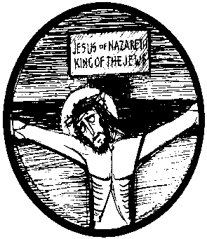
The year of Saint Luke ends with a characteristic take on the feast of Christ the King: in Luke’s gospel we are so familiar with seeing and hearing the voiceless, the rejected, those whom society puts in second place: how suitable, then, that on the feast of the King of all Creation we see him at his most vulnerable – on the cross, with only an abrupt inscription to announce that he is the King. He is King because of the work he has done, which is described by Saint Paul in the Second Reading: “all things [are] reconciled through him and for him … when he made peace by his death on the cross.” Next week, when we re-enter Advent and a new Liturgical Year, we will be thinking of the King who will come again: though he will come as his disciples saw him go at the Ascension, the marks of the cross will still be visible for all time, to remind us of the one who came to reunite all Creation, especially frail human creatures.

Liturgy & Activities This Week  Sunday Cycle C; Weekday Cycle 2; Divine Office Week 2  Sunday Missal: page 514; Readings 520; Preface 523 |  | Prayers Please  Sick: Mary Leigh, Joan Coles, Isabelle Owen, Laura Shuttleworth, Tony Winstanley, Bernard Holder, Eileen Murphy, Maureen Kennedy, Joan Pearce, Peter Cranmer, Pauline Bowling, Caroline Garside, Sarah Parkinson, Mary Long, Linda Southern, Rita Brooks, Callum Fazackerley, Elaine Jansen, Bernard Corri, Winifred Coyle, Josephine Knowles, Rita Bell, Mary Cassidy, Derek Crompton, Roy Shepherd, Tony Wright, Janet Rabbett, Mike Greenhalgh, Barbara Stoppard, June Dawson, Greta Barlow, Cassie Wilson, Christine Hasleden, Suzanne Freeman-Hill, Josephine Gell, Jude McCann Brown, Ann Cunliffe, John Pryor, Marie France and all who are sick or recovering from serious illness.  Lately Dead: Angela Sharples, Elizabeth (Betty) Taylor, Anthony Axford, Thomas Hodgkiss  Anniversaries: Graham Taylor, Nance Tabiner, Jack Gallagher, Philip Southern  Mass Intentions: Graham Taylor (20th Anniversary), Nance Tabiner (10th Anniversary & Birthday Remembrance), Elizabeth Betty Taylor, Philip Southern, Anthony Axford
Sunday  Youth Day | 9.15am Mass (SJ) - With Children’s Liturgy  11.15am Mass (SB) - With Children’s Liturgy  5.30pm REIGNITE Mass (Salford Cathedral)  A Day of Special Prayer for Young People
Monday (21st)  The Presentation of the Blessed Virgin Mary | 9.30am Mass (SB)  7.45pm SVP (SJ)
Tuesday (22nd)  St Cecilia | 2pm Meditation (Harbour Room)  7pm Mass (SJ)  7.15pm SVP (SB)
Wednesday (23rd) | 9.30am Mass (SJ)  7.15pm Meditation (Harbour Room)
Thursday  (24th) St Andrew Dung-Lac | 9.15am Mass (SB)  2pm Funeral Service for Thomas Hodgkiss (Overdale)
Friday (25th) | 9.30am Mass (SJ)
Saturday(26th) | 11am Annual Mass for the Lately Deceased (SJ)  2pm Baptism (SJ)  5pm Mass (SC) – With Children’s Liturgy  6.30pm Community Makes Music Concert (The Victoria Hall, Bolton) – See posters for details
Next  Sunday (27th)  First Sunday of Advent | 9.15am Mass (SJ) - With Children’s Liturgy  11.15am Mass (SB) - With Children’s Liturgy
Cycle of Prayer Part 6 (of 6):
We pray especially for: the spread of the Gospel; the harvest; the fruits of human work & the reverent use of creation; justice and peace in the world; all victims of war; young people; prisoners & their families

Parish Priest: Rev Canon Michael Cooke VG
Assistant Priests: Rev Seán O’Brien & Rev Francis Parkinson
Parish Office: St John’s Presbytery, The Crescent, Bromley Cross, Bolton BL7 9JP
Tel: 01204 301927 E-mail: office@sbsj.org.uk Website: www.sbsj.org.uk
Salford Roman Catholic Diocesan Trustees Registered Charity – 250037 Diocesan website: www.salforddiocese.net

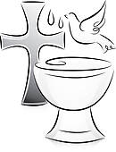
Congratulations: To Sienna Grace Price who was baptised at St Brendan’s last Saturday and to Jack David Crombleholme who was baptised at St Brendan’s last Sunday. We pray that they and their families will continue to grow in faith.

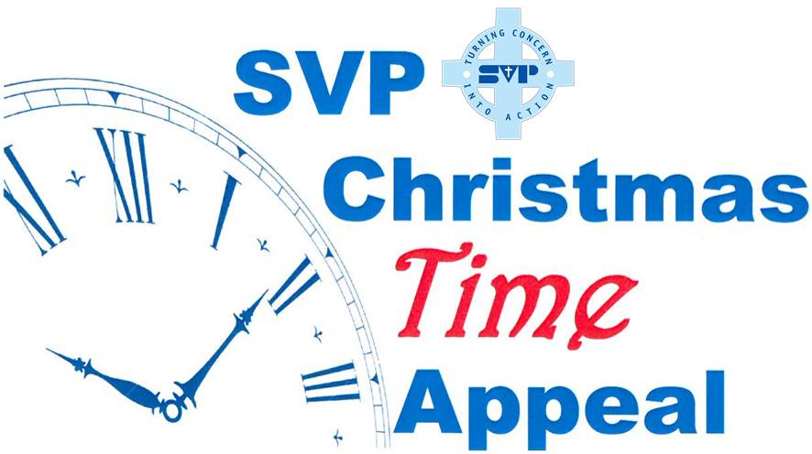
The St Vincent de Paul Society has launched their Christmas Time Appeal, but they’re not asking for money. Instead they’re asking for parishioners to give a little of their time to help others by joining our parish SVP group. As you plan your Christmas celebrations, spare a thought for those who dread the festive season. For many it’s a time of profound loneliness and solitude, while for others it means not being able to afford the family presents or delicious foods that the rest of us take for granted. But giving a little of your time to help those in need could help change that and it might be the best gift you’ve ever given. To find out more contact any member of the SVP.

The Destitution Project: There will be a joint food/clothing collection during December at each of our three churches. The items particularly needed at the minute are: rucksacks, underpants, hats, gloves, scarves, jeans and trousers, sweaters, waterproof and warm coats (all medium), sunflower or vegetable oil, sugar, tuna and especially sardines in oil. Thank you for your continued support
Churches Together in Harwood
Helping Urban Outreach

This year, St Brendan’s have promised to provide 435 cartons of chicken gravy granules to help towards providing Christmas dinner hampers for needy families. Your generosity, in the past, has been outstanding and we would appreciate your efforts again this year. The collection will begin this Sunday (20 November) and continue until 4 December. Thank you

SVP Annual Mass for the Deceased: Will be held on Saturday 26 November at 11am in St John’s Church.
Think Vocation
Our Holy Father is the leader of the Universal Church, of which Christ is the Head and Universal King. Through the power of the Holy Spirit, the Church has a presence in almost every country of the world now. As we give thanks for the Year of Mercy initiated by the Pope, we reflect on how our own faith in the Lord Jesus has grown. Let us pray for our Holy Father, that his faith will always be strong and that he will continue to lead the Church with zeal and fervour and proclaim Christ’s love for all people.

Marriage Matters
Let us radiate His life and light and goodness: ‘’Today you will be with me in paradise’ Jesus’ words as He hung on the cross; even in His agony, He still chose only to love. Through Him, we are given the strength to bear anything joyfully; with the saints we ‘inherit the light’. Today, let us radiate His life, light and goodness, acknowledging Him as our Lord and King.
CAMEO

A huge thank you to all those who came to support the recent auction. The amount raised for the SVP was £220 which was wonderful!
The next meeting will be on Tuesday 6 December (2pm-4pm) and will be a Christmas Decoration Demonstration by Margaret Fazackerley. All welcome
The Resurrection (Voskresenije) Choir
of St Petersburg
Return to
St Mary’s Church, Horwich
Thursday 24th November 2016 – 7.30pm
Tickets £10 - available by contacting 01204 468209
or emailing stmaryshorwich@gmail.com

For more information about this wonderful choir visit: voskresenije.blogspot.co.uk
Readers and Eucharistic Ministers for Next Weekend (26/27 November)
Mass | Reader | Eucharistic Ministers
5.00 (SC)  9.15 (SJ)  11.15(SB) | M Mayberry  A Gracie  F Doloroso | P & F McDowell  E Rothwell, T Armstrong,  A Gracie, M Fau-Goodwin,  A Rawlinson, M Cropper  T Smith, J Proctor, T Proctor,
Christmas Toy Collection: Following the overwhelming generous response to this special toy collection last year, we have been asked if we would hold another collection of newly purchased toys in aid of Fortalice. Fortalice provides frontline services for women and children who are affected by or who are fleeing domestic abuse. As the women and children have often lived a deprived and abusive life with little in the way of presents for birthdays or Christmas, Fortalice is always delighted to receive donations of toys and presents to ensure the residents in the refuge have a Christmas most of us would take for granted. Without the generosity of people in the local community, the charity would not be able to survive or give parents and children a new experience of receiving individual presents. We will hold the toy collection at our Saturday and Sunday Masses on the 10 & 11 December and a representative from Fort Alice will give a short talk. Thank you
Christmas Draws

St Columba’s: Tickets are now on sale after Mass.

St John’s: Tickets will be available after the 9.15am Masses. Please do take some tickets to sell to your family and friends. There is a list available for anyone wishing to donate prize vouchers. Thank you for your support

St John’s School Christmas Fayre: Will be held on Friday 2 December (3.30pm-5.30pm). As well as all the traditional stalls, our school choir will be singing. All welcome!

Christmas Window displays (St Brendan’s): You may have noticed that some new plinths were made for the window ledges at St Brendan’s. Poinsettias are going to be placed on these at Christmas time and if anyone would like to sponsor one (in memory of a loved one) please fill in a form at the back of church. Thank you.

A Journey for Advent: Each Monday evening in Advent, there will be time for reflection on Pope Francis’ The Joy of the Gospel. All are welcome to come along and the first one will start on Monday 28 November (7.30pm-9pm) in the Harbour Room at St Brendan’s.

