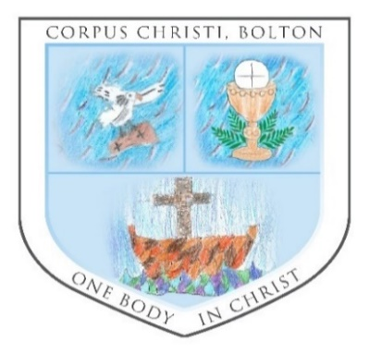

### Salford_Diocese_Logo

### **Parish of Corpus Christi, Bolton**

St John, the Evangelist, Bromley Cross, St Columba’s, Tonge Moor

and St Brendan’s, Harwood

**3 April 2022**

**Fifth Sunday of Lent**

|  |
| --- |
| **Masses this Week**  *Sunday Cycle C; Weekday Cycle 2*  *Divine Office Week 2*  **Readings:**  Isaiah 43:16-21; Philippians 3:8-14  John 8:1-11  *Roman Missal 582; Readings Page 589*  *Preface: Page 38-39* |
| **Sunday 3 April**  9.30am Mass (SJ)  11am Mass (SB)  12.30pm Baptism (SB)  3pm Stations of the Cross & Benediction (SB) |
| **Monday 4 April**  6pm Mass (SJ) |
| **Tuesday 5 April**  9.30am Mass (SB) |
| **Wednesday 6 April**  **8.30am Mass (SJ) – (Please note)**  10am Funeral Service for Terry Gillett (SB) |
| **Thursday 7 April**  9.30am Mass (SB) |
| **Friday 8 April**  No Mass Today |
| **Saturday 9 April**  11am-11.25am Exposition & Adoration with Confession (SJ)  11.30am Mass (SJ)  4.20pm-4.50pm Confession (SB)  5pm Mass (SB) |
| **Sunday 10 April – *Palm Sunday of the Passion of the Lord***  9.30am Mass (SJ)  11am Mass (SB)  2pm Churches Together in Harwood Palm Sunday Walk |

There is a line from Isaiah which speaks to me of the power of the Sacrament of Reconciliation “No need to recall the past, no need to think about what has gone before”. It reminds me that the forgiveness that our loving Father pours into our lives when we seek Him in reconciliation makes of the past a distant country, one where we need never to walk again. In another line Isaiah prophesises “I am making a road in the wilderness, paths in the wild”; each time we seek

reconciliation a new road is built that will keep us in God’s love if we choose to follow Him. We

have God’s promise that he will provide a light, that all we need to do is open our eyes to see it.

He will take us from the wilderness of our lives and create a new way for us to follow if we allow

him into our lives.

Paul knew these roads, these paths; he is a reminder to us that God’s forgiveness is for everyone no matter our past lives. Paul, a devoted follower of the law, has a new path, one

which may cause him pain and suffering but one he will gladly follow if he can win the prize he is

racing for. His life, like ours, will take many twists and turns, it will be far from easy, but he

sees the finish, when he can find his rest in Christ Jesus.

There is a certain tension in the Gospel passage from John. Once again Jesus is tested by the scribes and pharisees, once again they seek to undermine his authority, to question his teaching.

The woman caught in adultery is their victim, condemned for an act of sin, the punishment for

which is death by stoning. They call on Jesus to confirm this law, a verdict without forgiveness, without sympathy, just the certainty of a brutal, painful execution by the mob. By a single sentence Jesus silences them, opening their eyes to their own faults. One by one they turn away chained by their own sins. It can be difficult to accept that God’s love can free us from even the most dreadful of sins, but if we have faith, and we trust in God then we too can walk the road of forgiveness and leave our sins behind us in the dust of the road. ***David Frank***

**Parish Contact Details**

**Parish Priest: Fr Alfred Rebello**

**Parish Office: St John’s Presbytery,**

**The Crescent, Bromley Cross, Bolton BL7 9JP.**

**Tel: 01204 301927. E-mail: office@sbsj.org.uk**

**Website: www.sbsj.org.uk**

**Salford Roman Catholic Diocesan Trustees Registered Charity – 250037**

**Diocesan website:** [**www.dioceseofsalford.org.uk**](http://www.dioceseofsalford.org.uk)

|  |
| --- |
| **We pray for all the sick and housebound in our parish, and other relatives and friends:** Jackie Harte, Moya Fau-Goodwin, Anne Killeen, Fred & Joyce Heywood, Emily Martin, Pat Margiotta, Mary Bagg, Frances Skemp, Kathleen Banks, Penelope Booth (poorly infant), Colin Markland, Joan & Edwin Rankin, Philip Anderson, Vincent Hopkinson, Irene Clappison, Dorothy Killoran, Frank & Pat McDowell, George Denton, Richard Crichton, Josephine Ward  **Lately Dead**: Mark Strickleton, Terry Gillett, John Sissons, Frances Lansdale, Patricia Ashton, Fr Pat Quinlan, Tom Parker  **Anniversaries:** Bert Winstanley, Maureen Southworth, Daniel & Veronica Evans, Jim Smith  ***May They Rest in Peace***  **Mass Intentions**: Mark Strickleton, Bert Winstanley, Terry Gillett, Maureen Southworth, Daniel & Veronica Evans, In memory of Jack & Nellie Shechter, Jim Smith |
| **During Ordinary Time; we pray for:** Candidates for the Sacraments; women; the needy & hungry of the world; penitents & wanderers.  ***At this present time, we pray for peace and an end to the conflict in Ukraine*** *Holy Michael the Archangel, defend us in this day of battle. Be our safeguard against the wickedness and snares of the devil, and do thou prince of the Heavenly Host by the Power of God thrust down to Hell Satan and all wicked spirits who wander through the world for the ruin of soul. Amen.* |
|  |
| **Hope In The Future:** Let us pray for the people of the parish of St Augustine, Manchester, with Fr Michael Deas, their parish priest, and the Daughters of Charity of St Vincent de Paul, and St Wilfrid’s Primary School. May they show to others the gentle liberating mercy of God. |
| **Offertory:** We are always extremely grateful for all you do to help us financially. Donations can be made by posting through the presbytery letter box, by post or alternatively they can be made through Salford Diocese website, or by setting up a bank standing order. Thank you  **Cheques: Please make all cheques payable to *Corpus Christi*. Thank you** |
| **Prayer Resource -** For those at home the best resource for Sunday worship at home is through the **Universalis website**  ([**https://universalis.com/mass.htm**](https://dioceseofsalford.us6.list-manage.com/track/click?u=76e219dab8653b775ba8aac4c&id=330d8e52b9&e=b83d5e6119)) |

**Congratulations:** To Louie Joseph Sharp and Margherita Laura Brooks who were Baptised last week. Let us pray that they and their families continue to grow in faith.

**Offertory Envelopes:** The envelopes for the next financial year are now available for you to take. Thank you for all your contributions.

**Churches Together in Harwood Palm Sunday Walk:** Meeting at Christ’s Church, Harwood (with a short service) at 2pm, the walk will continue down Hough Fold Way to St Brendan’s for a short reflection, then on to Harwood Methodist for Hot Cross Buns. All are most welcome and we Look forward to all joining together again!

**Thankyou: For the wonderful turn out at the coffee morning this week. The amount raised was £175 which will be sent to Caritas (Salford) in response to their Ukraine appeal.**

**Harbour Room Book Club. Early notice:** The next few meetings are as follows: -

27 April- The Salt Path by Raynor Winn. (non-fiction)

25 May- The Keeper of Lost Things by Ruth Hogan.

29 June- Circe by Madeleine Miller.

Meetings are always on the last Wednesday of the month and begin at 1pm. Everybody is welcome and a special thank you to all those who have supported the club during these trying times.

**A Murder Mystery Play**

***Who Killed The Farmer*?**

This hilarious murder mystery play will be performed on Friday 29 April at Dunscar Conservative Club commencing promptly at 7.15pm with supper provided and prizes for the winning table. This event is being presented to help restore our community spirit following the ‘Covid’ lockdown and to provide Fr Alf with some additional funds for use in our parish. In order to attract a ‘Full House’, tickets will be sold at the very reasonable price of £6 (numbers are limited) and will be on sale after each Mass. Because of the audience concentration required, this will be an ‘Adults Only’ evening. Please support if you possibly can. God Bless, Terry Smith 01204 305832

**Comboni Mission Appeal:** Let us welcomeSr Aurora Salgado this weekend, who will talk about the work of the Comboni Missionary Sisters. There will be a retiring collection after Mass and will be left open over the week.

**200 Club Subscriptions:** If you have decided not to re-join 200 Club, please contact the Parish Office or Ann Gracie on 01204 302912 /07528027295**.** Thank You

**St Brendan’s After Mass Coffee:** Would you be able to spare some time to help with Coffee after Sunday Mass at St Brendan’s? If you are interested, please contact the parish office. Many Thanks.

**Christian Meditation**: Tuesday 5 April at 7.30pm (St John’s)

**'Prepare for Easter'**: To be held at St John Fisher, Kearsley on Friday 8 April at 7pm. This will be a reflection for Easter with a special remembrance for those in Ukraine and all those who died during the pandemic. There will be prayers and music. All are welcome and refreshments will be available afterwards for those who want to stay

**Caritas Diocese of Salford response to war in Ukraine:** Caritas Salford has launched an appeal for funds which will be available to assist those who will be hosting families/individuals with any practical support as their guests re-settle. To read the latest information, and to donate, please visit their website for updates:

[https://www.caritassalford.org.uk/ukraine-crisis/](https://caritassalford.us2.list-manage.com/track/click?u=88f66394d53d39d0a756488c6&id=11d1e110bd&e=3ca0456041)

**Formation Series: Fr Gerard Kelly - Personal Encounter with Jesus**: *Wednesday 27 April, 7.30pm – 9pm. Cathedral Centre, Salford, M3 6DP and via Zoom.*  Throughout Stage Four of our Hope in the Future journey, we will have several opportunities to explore our faith and role as missionary disciples through our formation series. Fr Gerard Kelly will lead a reflection about having a Personal Encounter with Jesus.  
Tea and Coffee will be available from 7pm. Following the talk there will be chance to ask questions.  To register, please visit

[www.dioceseofsalford.org.uk/personal-encounter-with-jesus/](http://www.dioceseofsalford.org.uk/personal-encounter-with-jesus/)

**Divine Renovation UK Open House:** *Salford:* *Cathedral Centre (3 Ford Street, Salford, England, M3 6DP), Saturday, 14 May, 9.30am - 5pm.*Explore ideas on how to breathe new life into your parish with this day-long event. Connect with other parishes that have come alive by pursuing mission, hear inspiring stories, and be encouraged to start renewing your parish.

**Cost**: £35 per person, including lunch and refreshments. Discount available for parish teams of 4 or more (including parish priest) by using the code **PARISH4** at checkout.

**Find out more and register at**:

<https://www.divinerenovation.org/openhouse-druk>

**Date for the Diary:** The first ever *Caritas Lancashire 3 Peaks Challenge* hiking fundraiser will take place on Saturday 25 June 2022 from 8am until 6pm over 37km (23 miles) and 870m ascent. It will raise money for people across Salford Diocese who are facing crisis and disadvantage. Due to the challenging nature of this event, there will be a maximum of 50 adult-only participants. For more information and to register your place, visit:

[https://www.caritassalford.org.uk/caritas-lancashire-3-peaks-challenge-fundraising-event/](https://dioceseofsalford.us6.list-manage.com/track/click?u=76e219dab8653b775ba8aac4c&id=978a4da7c1&e=b83d5e6119)

**SVP Manchester Central Council Annual Festival – “True North”:** *Thornleigh Salesian College, Bolton, Sunday 24 April, 2pm*. Bishop John will celebrate Mass in the chapel at Thornleigh, followed by refreshments with a short meeting & discussion in the adjoining hall. It will be our first meeting of this kind for a couple of years and it would be lovely to see as many friends as possible alongside SVP members. All are welcome. It is a chance to catch up, to meet our two new Membership Support Officers, and to look at how we take forward our ambition for a dynamic, growing Society, as we emerge from Covid restrictions.

**Online Stations of the Cross Reflections from The Hidden Gem**: In the days leading up to Easter, the Diocese of Salford will be presenting a digital version of the Stations of the Cross using the striking paintings from The Hidden Gem Church, Mulberry Street, Manchester. The Stations will give people the opportunity to pray and meditate on Christ’s journey to the cross through the powerful reflections written by Bishop Brain. An introduction to the Stations will be posted on Sunday 3 April on the Diocese of Salford website and social media channels, with one station being posted each day until Easter Sunday. Visit [https://www.dioceseofsalford.org.uk/news/](https://dioceseofsalford.us6.list-manage.com/track/click?u=76e219dab8653b775ba8aac4c&id=2830cdfdb7&e=b83d5e6119) to follow.

**Young Adults Mass**: *St Augustine's Church, Grosvenor Street, All Saints, Manchester, M15 6BW Sunday 10 April, 5.30pm*. This Palm Sunday Mass will include a short talk on next year's World Youth DayAll are very welcome to attend.

[SalfordYoungAdults@vol.dioceseofsalford.org.uk](mailto:SalfordYoungAdults@vol.dioceseofsalford.org.uk)

**Ancient Byzantine Iconography course**  
A full, seven-day immersion in the spirituality and discipline of writing an icon in the Byzantine style, led by Deacon Nikita Andreyev, of the Prosopon School of Iconograph. Residential and non-residential options, from Saturday 25 June to Friday 1 July at the Christian Heritage Centre at Stonyhurst. For more info and to book,

<https://christianheritagecentre.com/events/iconography-course/>

**Eco-Gardening Training at Laudato Si' Centre**  
*Various dates beginning April, Laudato Si' Centre at Wardley Hall*. The Eco-gardening Essential Training programme enables gardeners of any skill level to confidently adopt sustainable gardening methods. Participants have the opportunity to learn the theory and practice of gardening with ecological patterns. The programme has been designed to skill people up while supporting the development of an eco-garden setting. Find out more and book at [https://northernschool.info/eco-gardening-course-laudato-si](https://dioceseofsalford.us6.list-manage.com/track/click?u=76e219dab8653b775ba8aac4c&id=f39c063c06&e=b83d5e6119)

**Easter Triduum**

**Maundy Thursday – 7.30pm** Mass of the Lord’s Supper & watching at the Altar of Repose until 10pm (St John’s)

**Good Friday – 3pm** Celebration of the Lord’s Passion (St John’s)

**Holy Saturday – 8pm** The Easter Vigil (St Brendan’s)

|  |  |  |
| --- | --- | --- |
| **Readers For (9/10 April 2022)** | | |
| **T Proctor** | **J Carroll** | **C Bridge** |

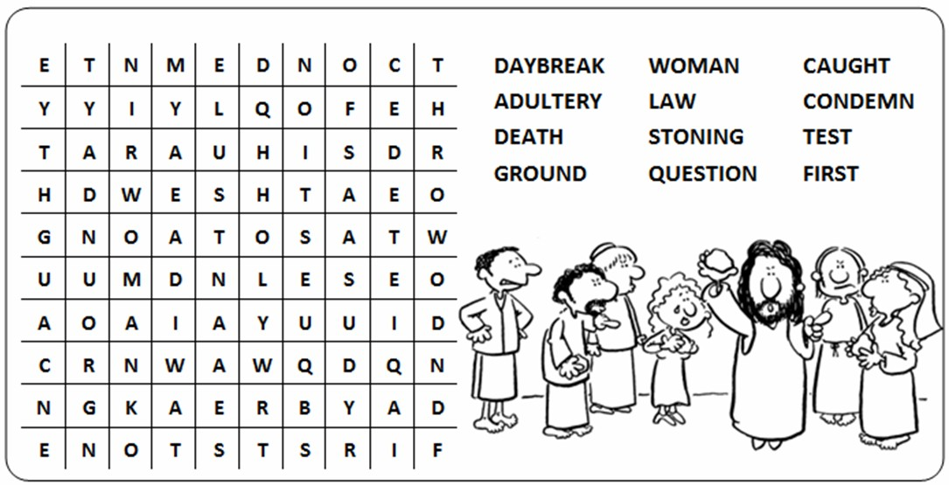****

**Thought for the Week**

“Yesterday is gone. Tomorrow has not yet come.

We have only today. Let us begin.”

**St Teresa of Calcutta**